What is a CSA?
Community Supported Agriculture (CSA)is a subscription-style farming partnership between CSA members(you!) and thefarmer.
Memberssignupearlyintheseasonfor weeklyCSA sharesthatlastduringthepeak-
growing season. In return for this early commitment, CSA members receive the freshest food possible, learn about new vegetables, explore recipes that you may not have tried before. In return,the farmersspend moretimeproducingthebestcropspossible.
Thisallows us to havemoremoney at the beginningoftheseason to coverstart-up costs like vegetable seeds.

What’s new for 2023!!

- Your choice of up to 10 items to mix and match (plants, herbs and flowers)
  - Sign up prior to December 31, 2022 and receive 10% off of your CSA share!!
- Sign up between December 31, 2022 and January 31, 2023 and receive 5% off your CSA share price!!
- 2 FREE MUMS in the fall as well as 2 carving pumpkins!!

Price and Benefits
A partoftheconceptof CSAmembershipisto support the farm financially at the beginning ofthe season (where most of our expenses occur). We understand that budgeting a full summer’s worth of produce costs into one payment can be a challenge,so we offer a payment plan with2installments. A down payment is due to reserve a CSA membership, with thebalancedue/finalpayment by March
1, 2023. Shares not paid in full by March 1,
2023 will be made available to memberson the waiting list, and your balance will be returned less a $20 administrative fee.

Our Growing Methods
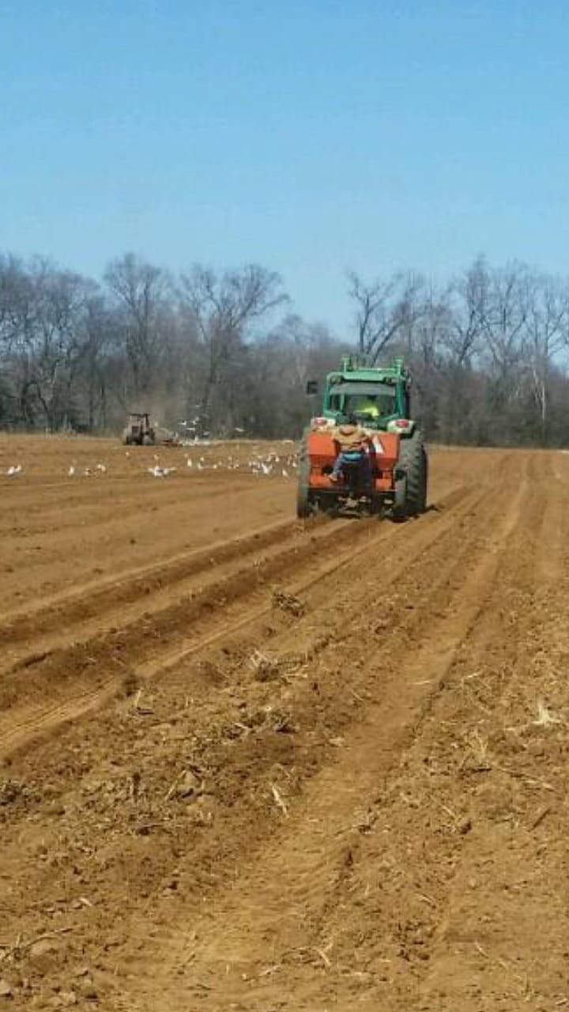
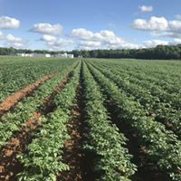
We are minimalists, which means we like to use the least amount of chemicals to grow our crops. However, we do use fertilizer to yield a large enough quantity of produce. If there is a problem with pests, we use the bare minimum amount of FDA- approved chemicals necessary to allow us to harvest our crops. We utilize organic methods as often as possible.
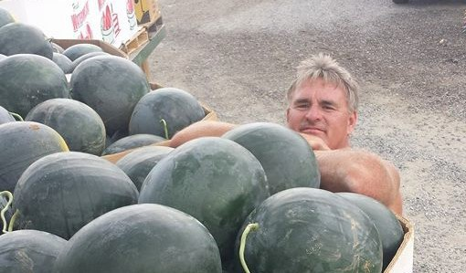
Your Farmer!!!

Is there any risk?
CSA members provide support to the farm,
while the farm works hard to provide a plentiful, consistent, and varied supply of farm fresh produce. We have more than 30 years in agriculture production, and many more years in farm stand and market experience. That being said, there is a small element of risk in a CSA membership: due to weather or other events beyond our control, there may be complications with some crops, and the forecasted share supply may have to be changed on short notice. We may bring in fresh, local produce from our partner farms to supplement for impacted crops.
C&T PRODUCE 2023 CSA PROGRAM

210 Chapel Green Road Fredericksburg, VA 22405

2023 CSA MEMBERSHIP
Member Information
Circle CSA Share Size* |  |  | Large Share | Small Share
Circle  Member Type* |  |  | New CSA Member | Previous CSA Member
First & Last
Name*
Email*
Phone*
Choose a Location to Pick Up Your CSA Share*
 | Long Market—Sunday (8-1)
 | Kingstowne-Friday (3-7)
 | Stafford—Wednesday (9-6)
 | Rick’s & Van’s-Tuesday (9-6)
 | Spotsylvania Regional Med. Ctr-Wednesday (2-6)
 | -Manassas-Saturday (8-1)
 | King George-Saturday (8-12)
 | Spotsy Market-Saturday (8-1)
 | Dale City-Sunday (8-1)
 | Del Webb-Thursday (8-1)
 | Fredericksburg-Tuesday (9-1)
 | Culpeper-Saturday (730-12)
 |  | Locust Grove-Sunday (930-130)
By completing this form, you are acknowledging that CSA members share in the seasonality and risks of the growing season, that C&T Produce strives to provide a diverse and generous supply of produce for 18 weeks, and that you accept the inherent risks of farming, which may impact crop yields. Membership is non- refundable.
X
*Fields marked with an * must be completed

18 MAIN SEASON WEEKS
START DATE: WEEK OF MAY 7, 2023

Please note: Email is the official form of communication for C&T Produce’s CSA program.
You can expect to receive weekly emails regarding your CSA share!

MEMBERSHIP OPTIONS:

LARGE SHARE:
Designed for a family of 4.

SMALL SHARE:
Ideal for a couple, a smaller family, or people
that eat out often.

BONUS OPTION:
Sign up before December 31, 2022 for our 2023 CSA program and receive $20 in C&T gift certificates for the 2023 season!

FOR REPEAT CSA MEMBERS:
Repeat CSA members that sign up before December 31, 2022 willreceive $30 in C&T gift certificates valid for the 2023 season!

Sample of 2023 Share Contents
Week 2: Tomatoes, spring onions, potatoes, broccoli, carrots, lettuce, swiss chard, asparagus
Week 7: Tomatoes, sweet corn, potatoes, broccoli, beets, cabbage, blueberries, onions
Week 10: Corn, cherries, onions, tomatoes, carrots, cauliflower,
peaches, grape tomatoes
Week 17: Apples, corn, bell peppers, watermelon, nectarines, eggplant, potatoes, winter squash
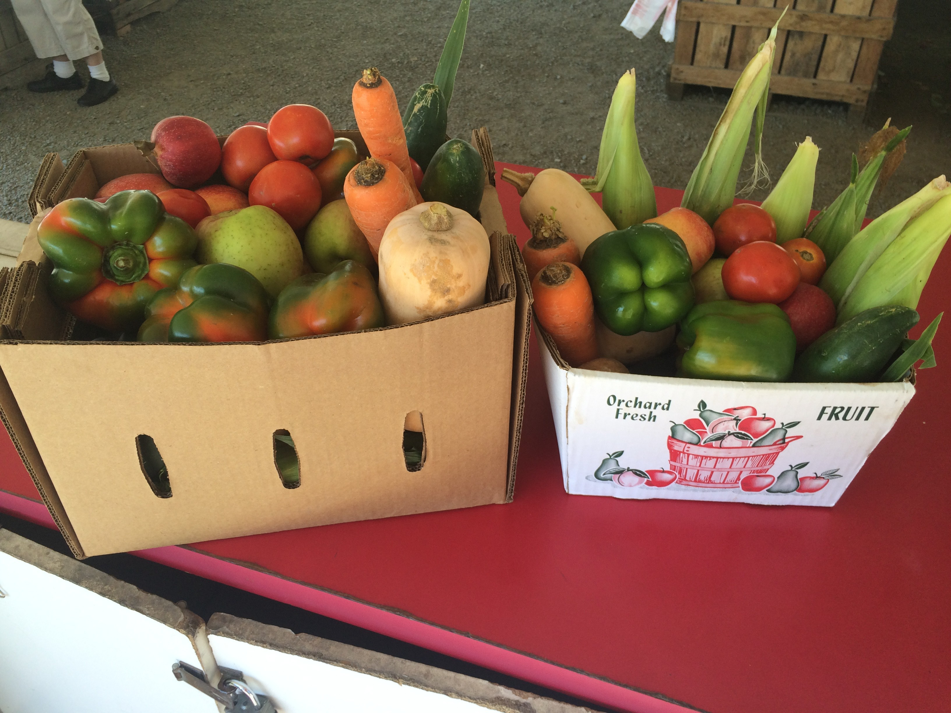

Pictured Above: Large and Small shares!

CSA MEMBERSHIP FEE
Large Share: $675 + tax
Small Share: $390 + tax

PAYMENT PLANS

LARGE SHARES:
Paid in Full: $710.75 (tax included)
Installment Option:
Down Payment: $355.37 Final Payment $355.38

SMALL SHARES:
Paid in Full: $410.75 (tax included)
Installment Option:
Down Payment: $205.37 Final Payment: $205.38
Down payment must be received by January 31, 2023 to reserve your CSA space; Final payment is due by March 1, 2023
METHODS OF PAYMENT
- Check by mail (our preferred method of payment!) Mail check & form to:
C&T Produce
210 Chapel Green Road

Fredericksburg, VA 22405
- Enroll online at CTProduceOfStafford.com (payment in full accepted via PayPal)

